Rolling correlation: EURUSD and GBPUSD
Method 05 / daily log returns / windows 20, 60, 100 / Short watchlist

Study setup
Logical pair: EURUSD , GBPUSD
Broker symbols: EURUSD_i , GBPUSD_i
Tier: Short watchlist (short_watchlist)
Snapshot: 2026-11-03_majors_alpari_D1
Timeframe: D1
Matched return window: 1999-01-05 to 2026-11-02 (UTC bar dates)
Matched return count (rows before rolling): 7202
Dropped unfinished last bar dated 2026-11-03 UTC after a tick-volume check against the prior complete day.
Rolling windows W: 20, 60, 100 trading days
Live-shaped n for each score: n = W (not the full history length)
Complete matched rows (CSV): EURUSD-GBPUSD_Rolling_D1.csv
Complete matched rows (HTML): EURUSD-GBPUSD_Rolling_D1_data.html

Method carried forward
Rolling Pearson r is computed on matched daily log returns of close, ln(close_t / close_t-1), in the broker quote direction. Quotes are not inverted. For each day t with a full window, r_W uses the last W matched return pairs ending at t. That live-shaped sample size is W (20, 60, or 100), not the full multi-year history. The first W-1 days have no score. r is symmetric under swap of the two symbols. A high |r| in one window does not prove cause, lead-lag, or a trading signal. Short windows are noisier; long windows are slower to reflect a break.
How to read a live day: after both daily candles close, the newest r_20 uses the last 20 matched log returns, r_60 the last 60, and r_100 the last 100. Compare those three to each other and to the full-sample baseline below. A break is when the short window moves far from the baseline or flips sign while the baseline was meaningful.

Full-sample Pearson baseline (method 01 v001)
Copied full-sample Pearson r for EURUSD-GBPUSD: 0.641738. This is a historical average link, not the live state.

Rolling results
W | latest_r | mean | median | min | max | std | pct_|r|>=0.4 | pct_|r|>=0.7 | n_roll
20 | 0.925234 | 0.652129 | 0.697956 | -0.5968 | 0.955992 | 0.203389 | 90.07 | 49.52 | 7183
60 | 0.875106 | 0.657666 | 0.678056 | 0.071472 | 0.923464 | 0.145895 | 94.22 | 43.95 | 7143
100 | 0.851407 | 0.659619 | 0.66872 | 0.235863 | 0.894682 | 0.13066 | 96.58 | 41.48 | 7103
n_roll is the number of days that had a complete window. pct_|r|>=0.4 and pct_|r|>=0.7 are the share of those days where the absolute rolling correlation cleared the threshold.

Conclusion
For EURUSD and GBPUSD, full-sample Pearson baseline r=0.6417. Latest rolling scores: r_20=0.9252, r_60=0.8751, r_100=0.8514. Stability: short window is much noisier than the 100-day window. Agreement with baseline: r_20=0.925 far from baseline (0.28); r_60=0.875 near baseline; r_100=0.851 near baseline. Tier line: watch — short window has pulled away from the full-sample baseline; treat the link as unstable until windows re-align. This is a monitoring summary, not a trade signal.

What to look at in this file next time
1) Latest r_20 vs r_60 vs r_100 in the results table. 2) Whether short-window latest has the same sign as the baseline. 3) The rolling chart for stretches where |r| collapsed. 4) The CSV if you need a different chart later.

Charts
Rolling Pearson r (20 / 60 / 100)
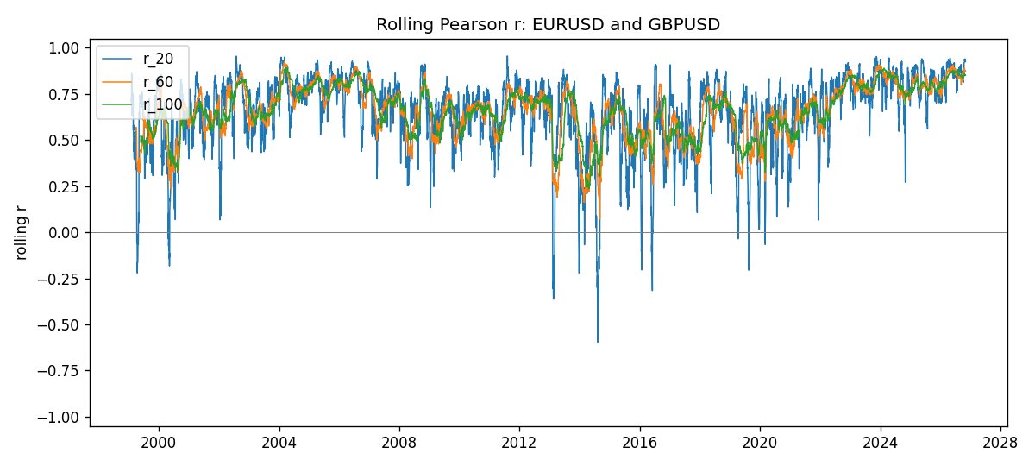
Daily closes

Daily log returns
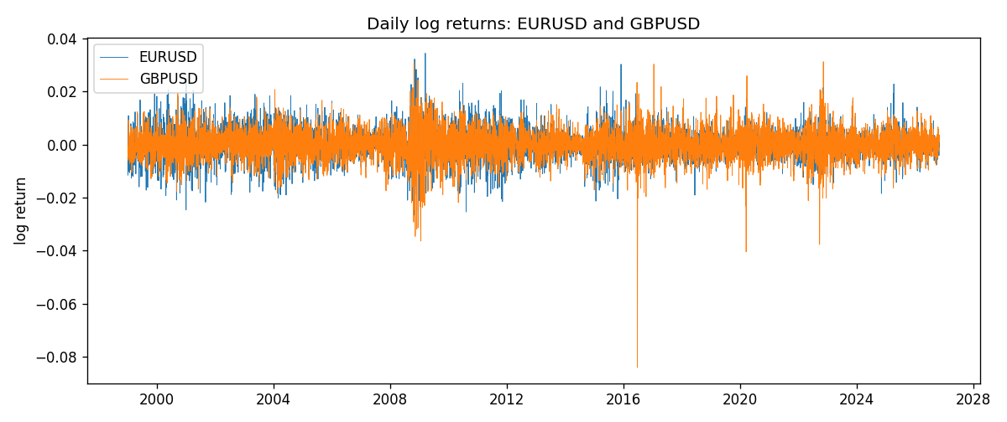

Data report
Every matched row with r_20, r_60, and r_100 is in the sibling CSV and HTML. This Word section holds column summaries and the first and last 15 rows of the rolling table.
Columns: time, EURUSD_close, GBPUSD_close, EURUSD_tick_volume, GBPUSD_tick_volume, EURUSD_log_return, GBPUSD_log_return, r_20, r_60, r_100
Column summaries
column | count | mean | std | min | 25% | 50% | 75% | max
EURUSD_close | 7202 | 1.18133 | 0.150856 | 0.8267 | 1.086 | 1.1661 | 1.29395 | 1.5997
GBPUSD_close | 7202 | 1.51615 | 0.218209 | 1.06879 | 1.32513 | 1.51133 | 1.6321 | 2.1065
EURUSD_tick_volume | 7202 | 102991 | 173402 | 218 | 9388.25 | 52708 | 99433.8 | 1.47163e+06
GBPUSD_tick_volume | 7202 | 94813.5 | 153540 | 62 | 9988.5 | 52886.5 | 91789.2 | 1.27337e+06
EURUSD_log_return | 7202 | -7.71e-06 | 0.00580133 | -0.0312382 | -0.00324586 | 0 | 0.00325471 | 0.0343318
GBPUSD_log_return | 7202 | -2.587e-05 | 0.00564523 | -0.0838824 | -0.00313091 | 3.124e-05 | 0.00317757 | 0.0311265
r_20 | 7183 | 0.652129 | 0.203389 | -0.5968 | 0.557825 | 0.697956 | 0.793419 | 0.955992
r_60 | 7143 | 0.657666 | 0.145895 | 0.0714724 | 0.567353 | 0.678056 | 0.766897 | 0.923464
r_100 | 7103 | 0.659619 | 0.13066 | 0.235863 | 0.576095 | 0.66872 | 0.766111 | 0.894682
First 15 matched rows
time | EURUSD_close | GBPUSD_close | EURUSD_log_return | GBPUSD_log_return | r_20 | r_60 | r_100
1999-01-05 | 1.1758 | 1.6547 | -0.00483605 | -0.00289663
1999-01-06 | 1.1623 | 1.6537 | -0.011548 | -0.000604522
1999-01-07 | 1.1712 | 1.6502 | 0.00762806 | -0.00211871
1999-01-08 | 1.1585 | 1.6405 | -0.0109028 | -0.00589542
1999-01-11 | 1.1503 | 1.6312 | -0.00710329 | -0.00568513
1999-01-12 | 1.1555 | 1.6349 | 0.00451037 | 0.0022657
1999-01-13 | 1.1681 | 1.6499 | 0.0108453 | 0.00913304
1999-01-14 | 1.1681 | 1.6531 | 0 | 0.00193763
1999-01-15 | 1.1563 | 1.6502 | -0.0101532 | -0.00175582
1999-01-18 | 1.1605 | 1.6522 | 0.00362569 | 0.00121124
1999-01-19 | 1.1603 | 1.6553 | -0.000172354 | 0.00187453
1999-01-20 | 1.1566 | 1.6472 | -0.00319393 | -0.00490538
1999-01-21 | 1.1601 | 1.6524 | 0.00302154 | 0.0031519
1999-01-22 | 1.1587 | 1.6565 | -0.00120752 | 0.00247817
1999-01-25 | 1.1552 | 1.6585 | -0.0030252 | 0.00120664
Last 15 matched rows
time | EURUSD_close | GBPUSD_close | EURUSD_log_return | GBPUSD_log_return | r_20 | r_60 | r_100
2026-10-13 | 1.11965 | 1.32534 | 0.0037403 | 0.00364343 | 0.881937 | 0.874938 | 0.84823
2026-10-14 | 1.11545 | 1.31884 | -0.00375823 | -0.00491647 | 0.863088 | 0.878462 | 0.85101
2026-10-15 | 1.12172 | 1.32757 | 0.00560531 | 0.00659764 | 0.916755 | 0.886327 | 0.856914
2026-10-16 | 1.12371 | 1.33257 | 0.00177249 | 0.00375921 | 0.919215 | 0.885823 | 0.857139
2026-10-19 | 1.12086 | 1.33024 | -0.00253946 | -0.00175003 | 0.921255 | 0.89097 | 0.859621
2026-10-20 | 1.12354 | 1.3377 | 0.00238817 | 0.00559234 | 0.923827 | 0.889997 | 0.859268
2026-10-21 | 1.12318 | 1.33937 | -0.000320467 | 0.00124763 | 0.92477 | 0.883856 | 0.857807
2026-10-22 | 1.12139 | 1.33967 | -0.00159496 | 0.000223961 | 0.939582 | 0.874951 | 0.8572
2026-10-23 | 1.11989 | 1.33684 | -0.00133852 | -0.00211469 | 0.930411 | 0.873706 | 0.85147
2026-10-26 | 1.11735 | 1.33359 | -0.00227066 | -0.00243407 | 0.931666 | 0.875991 | 0.852783
2026-10-27 | 1.11272 | 1.33044 | -0.00415234 | -0.00236484 | 0.932529 | 0.875909 | 0.85325
2026-10-28 | 1.1152 | 1.33254 | 0.00222629 | 0.00157718 | 0.939649 | 0.876083 | 0.853414
2026-10-29 | 1.11772 | 1.33733 | 0.00225714 | 0.00358819 | 0.936762 | 0.878154 | 0.852892
2026-10-30 | 1.11644 | 1.33913 | -0.00114584 | 0.00134506 | 0.934714 | 0.872259 | 0.850755
2026-11-02 | 1.11881 | 1.3406 | 0.00212057 | 0.00109713 | 0.925234 | 0.875106 | 0.851407

